Instances, Putty, Elastic IP

Creating Instance:

1. To Create Instance, Search Services --> EC2 and open it.

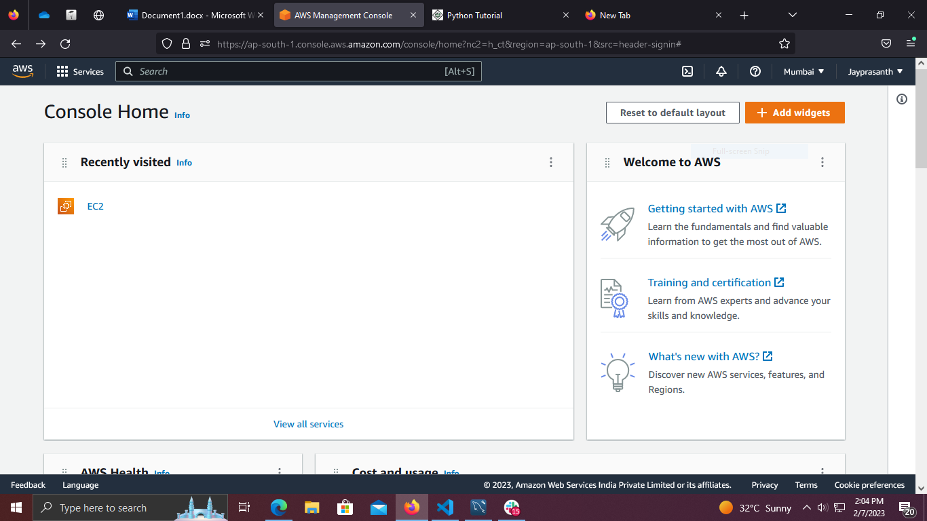

2. In EC2, Click Instances and open it.

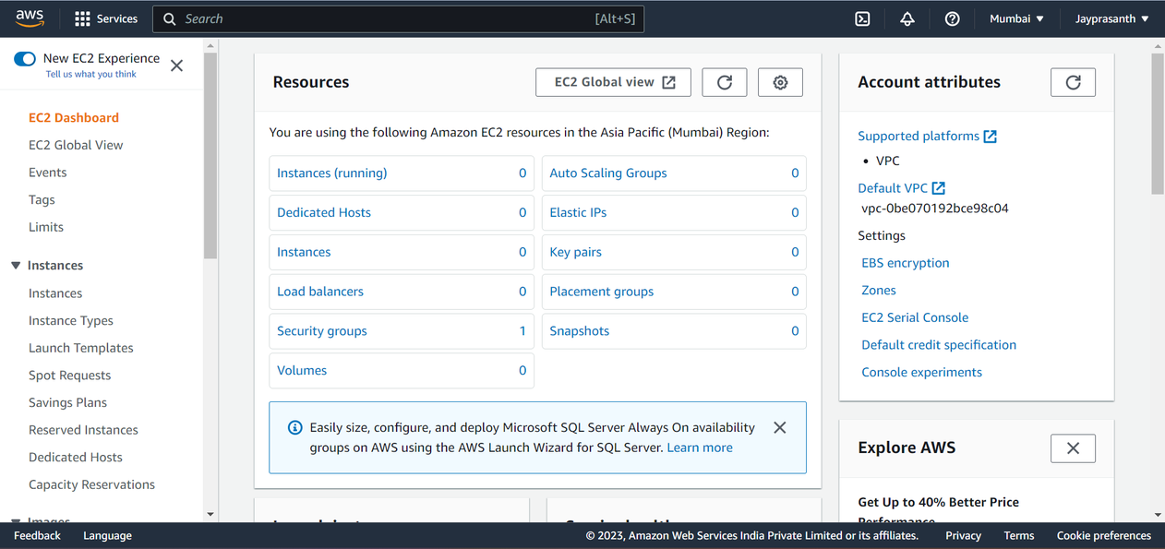

3. In Instances, there is Launch Instance Click on it.

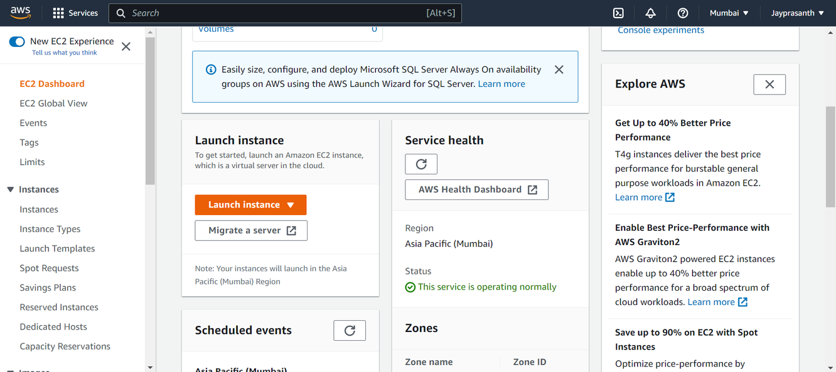

4.After open Launch instances, Name the instances.

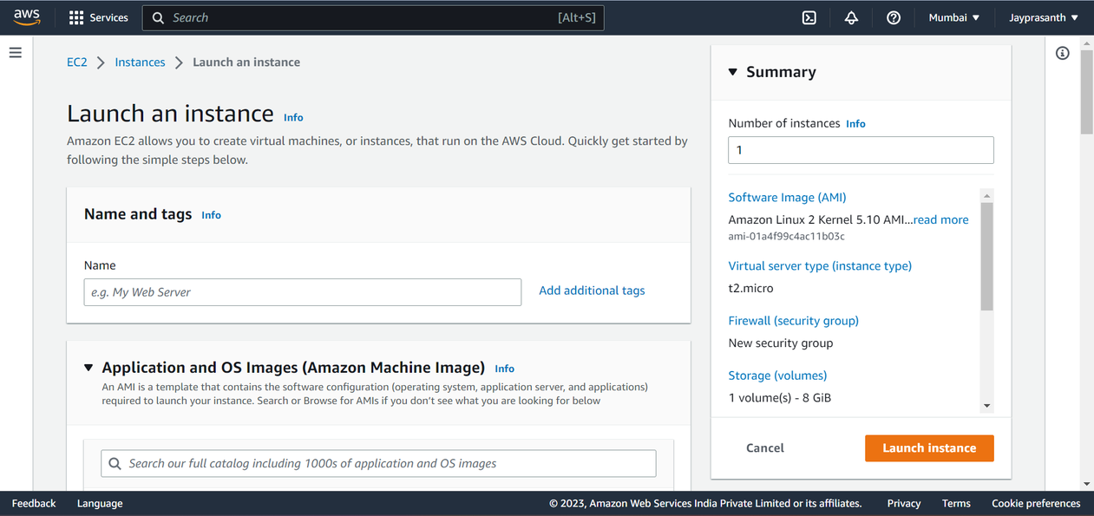

5.Name the Instances, what project you are taken. I just name it Demo.

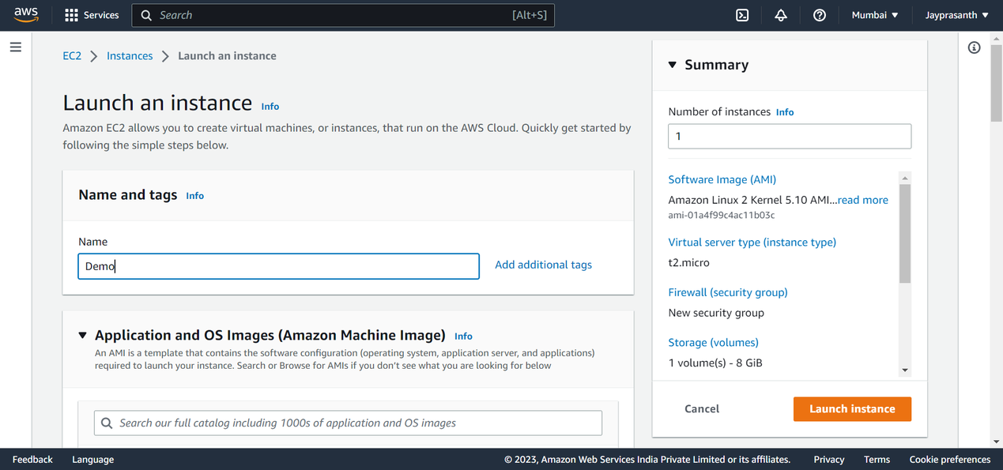

6. Scroll down, there is Application and OS, in that we choose OS which we want to run in virtual

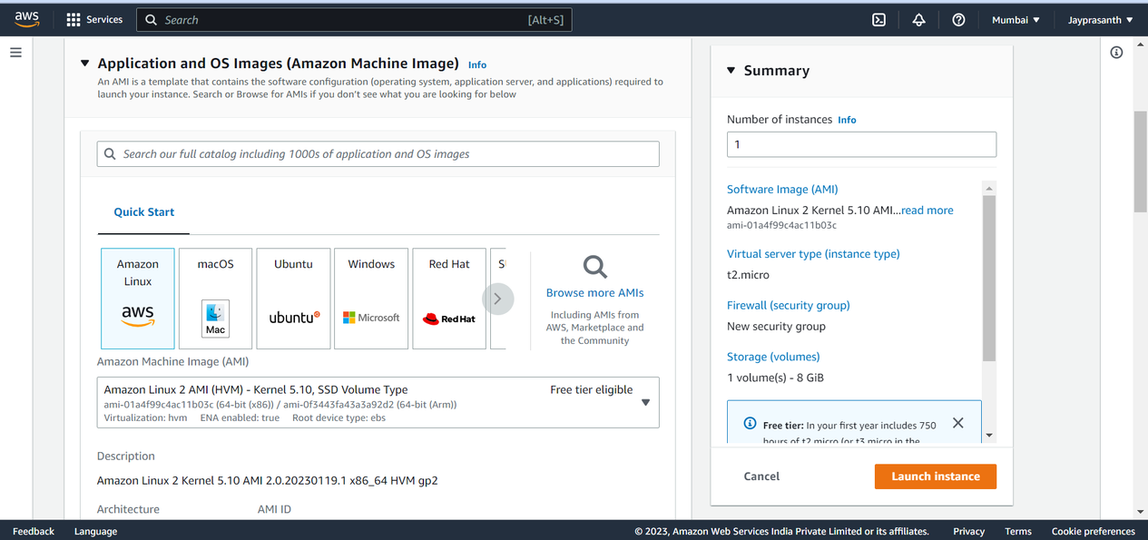

7.I select Amazon Linux free version and 64-bit processor

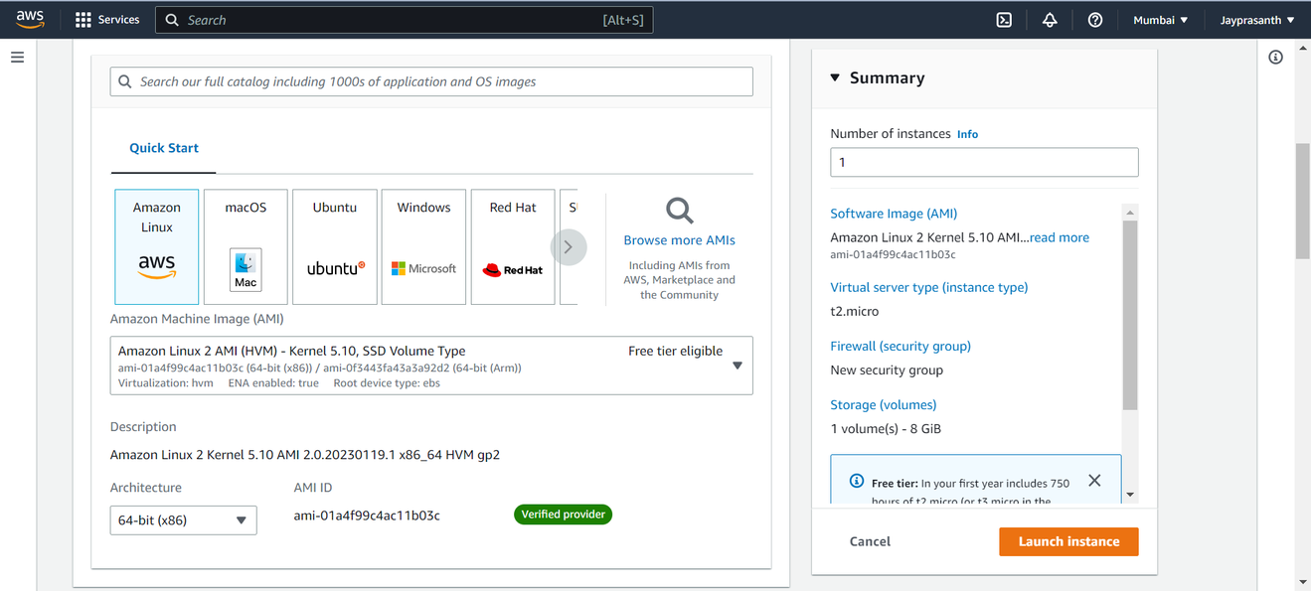

8.Then Instance type, I select t2.micro, it is virtual single computer and there is so many other like c5.micro it is like super computer.

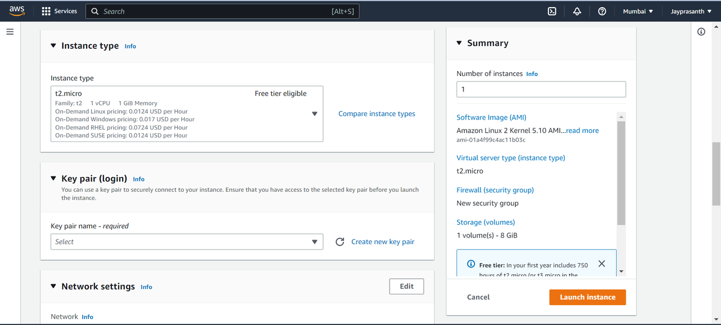

9.We need to create a Key pair for Instances and click it

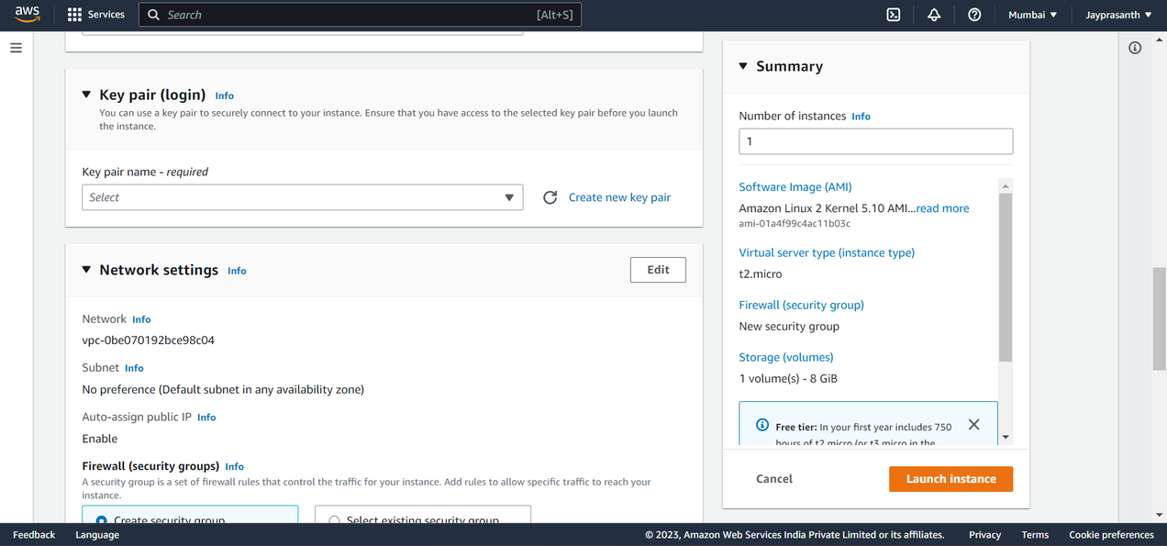

10.After clicking Create, this pop window shows.

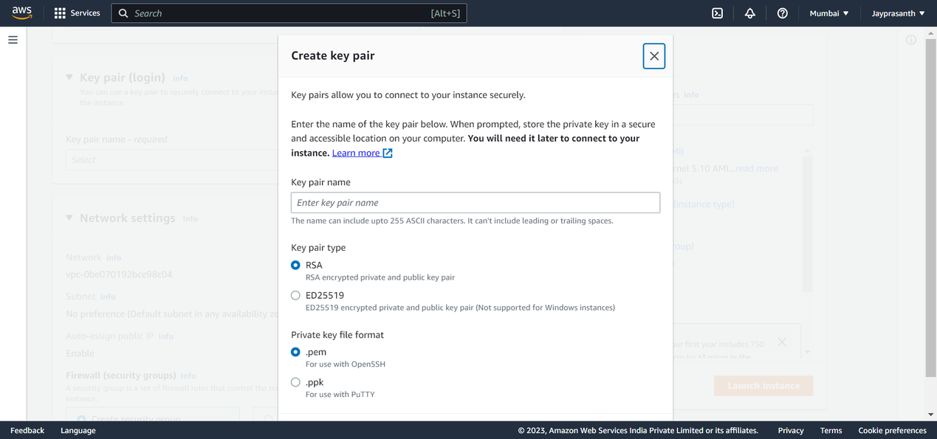

12.In that, We name it and choose RSA or ED22519 also .pem or .ppk,

In first choice RSA for Windows OS and ED22519 for Linux, In second choice .pem for Linux and .ppk for

Windows and Download it, Store in Secure folder.

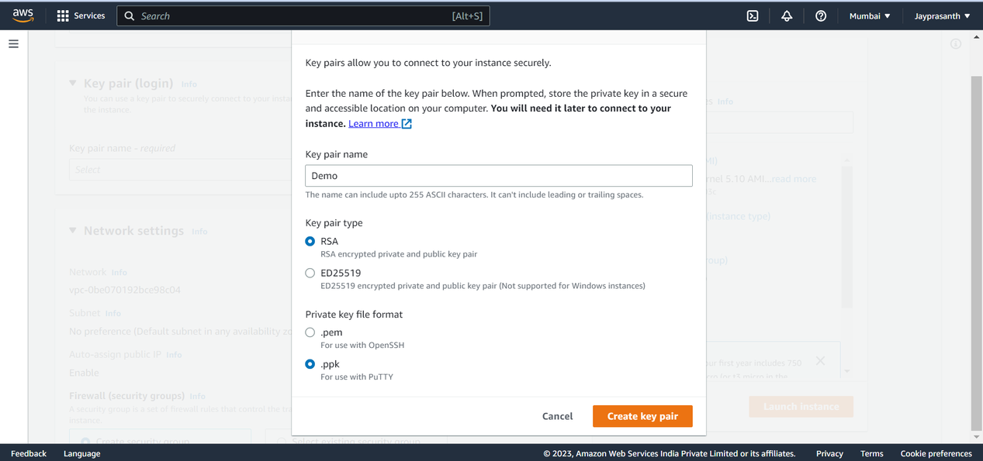

13.In network, Let it be Default.

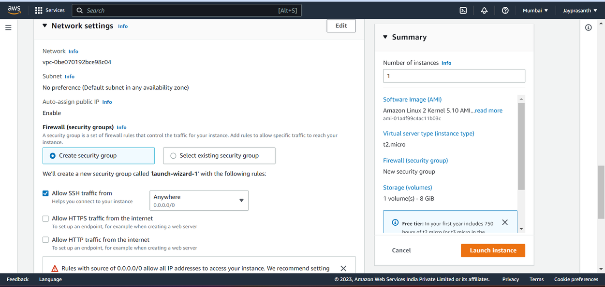

14.Storage - we go for free version is enough

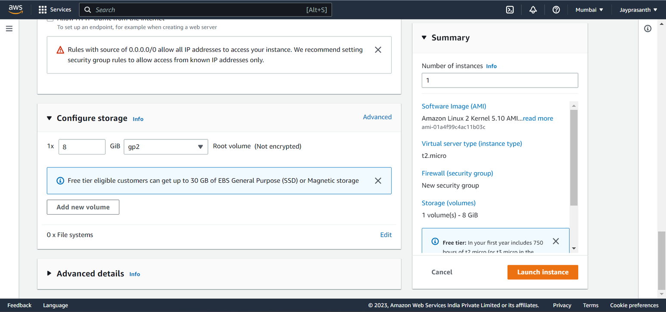

15.It is also in default

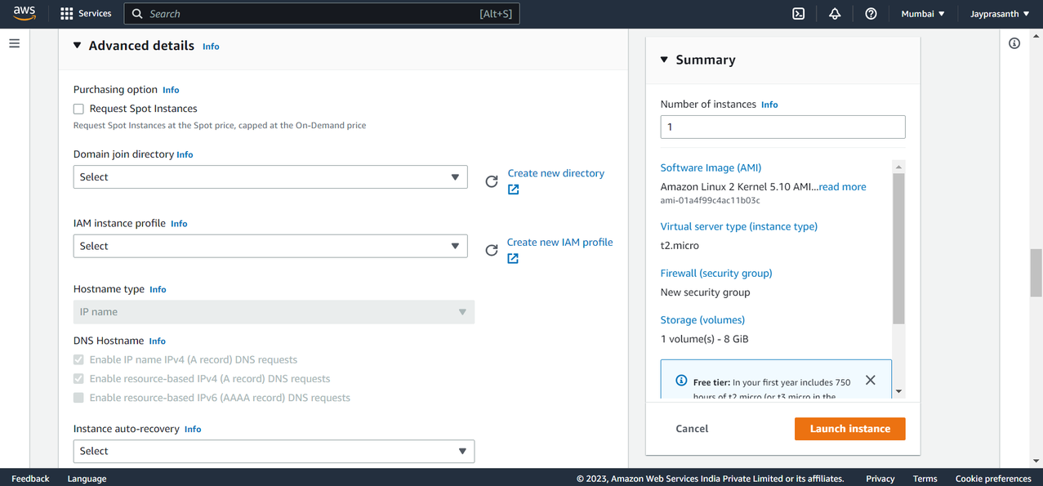

16.After all, we select how many instances we want and click Launch Instances

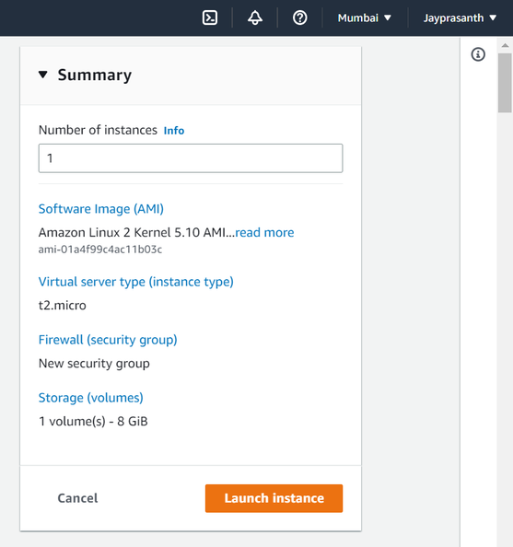

17. This window shows Instances is Successfully Launched

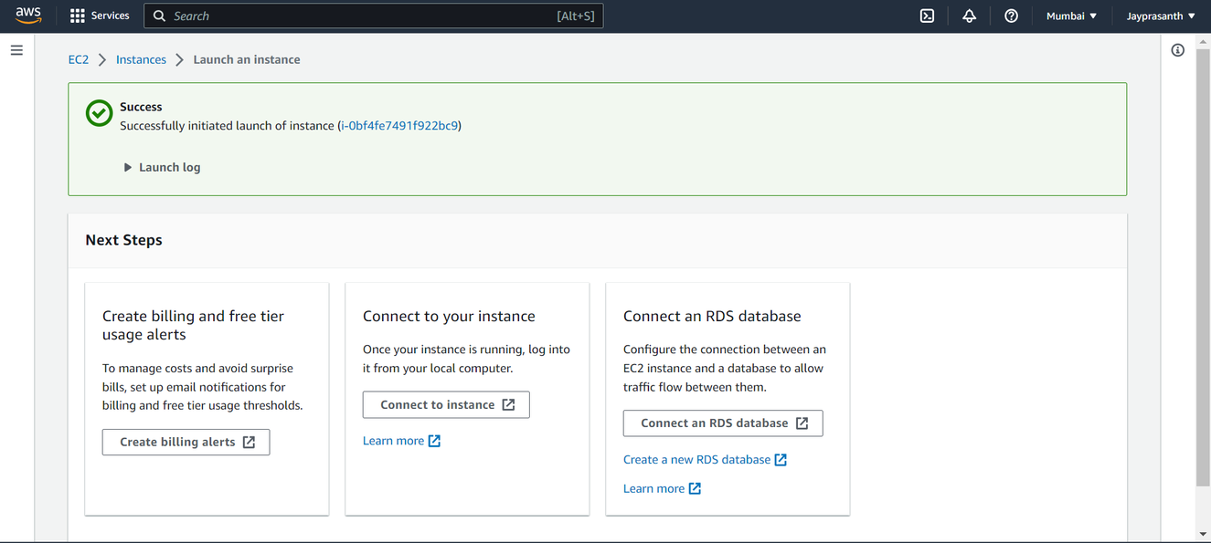

18.

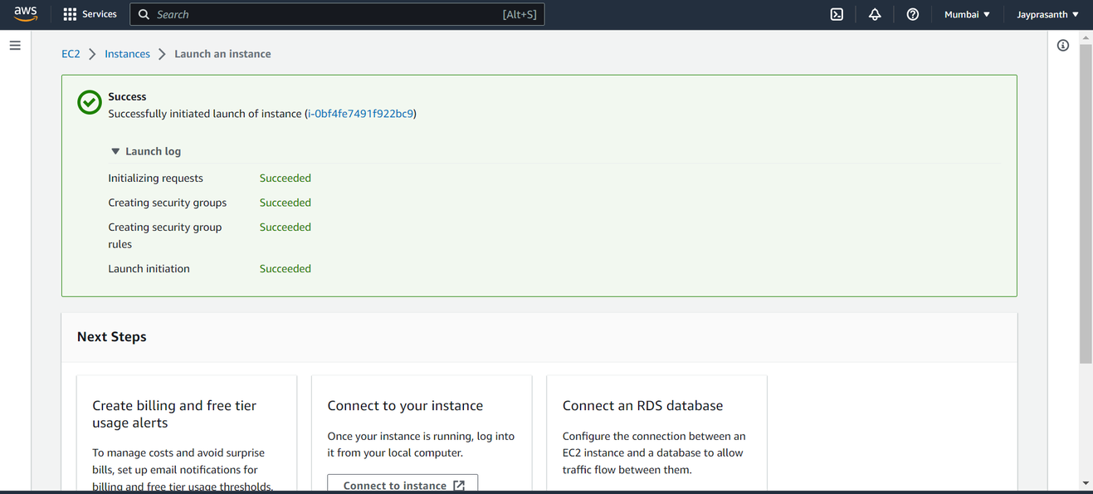

19.Running shows the Instances state

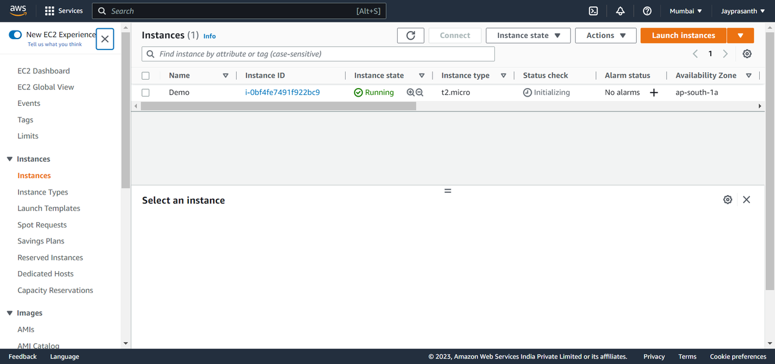

20.click the check box, it shows the IP address and ID.

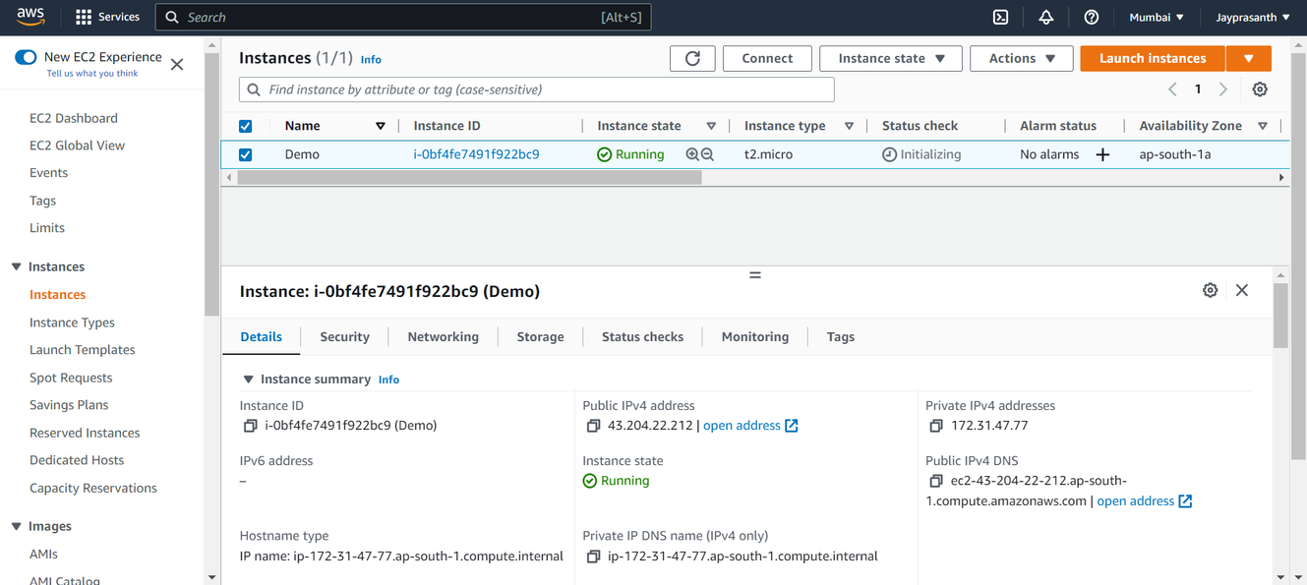

21. Then we Install the Putty In our Desktop

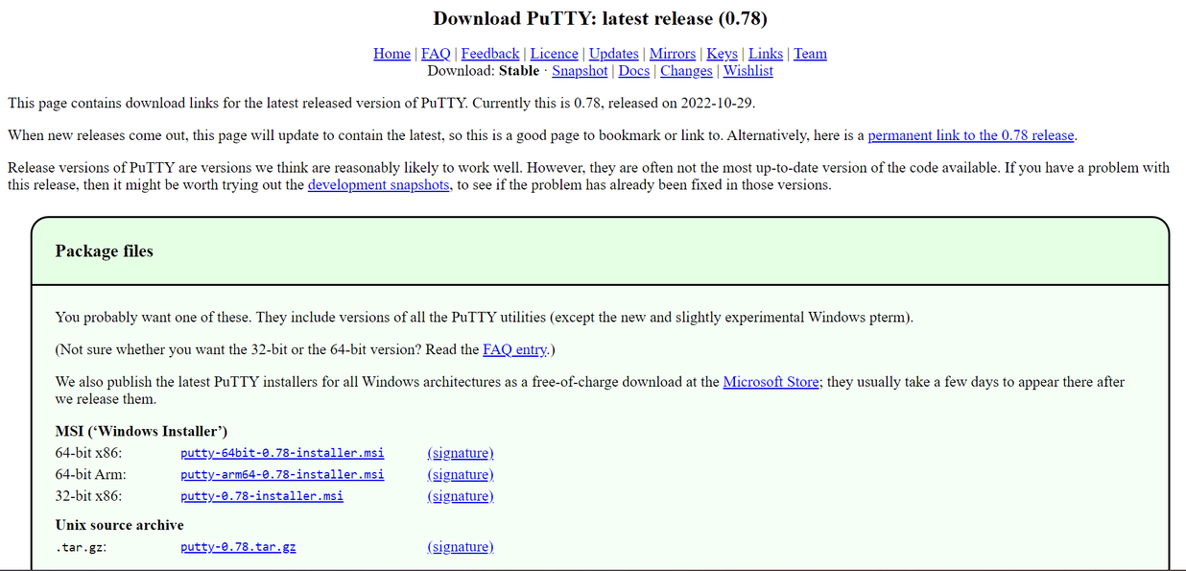

22.

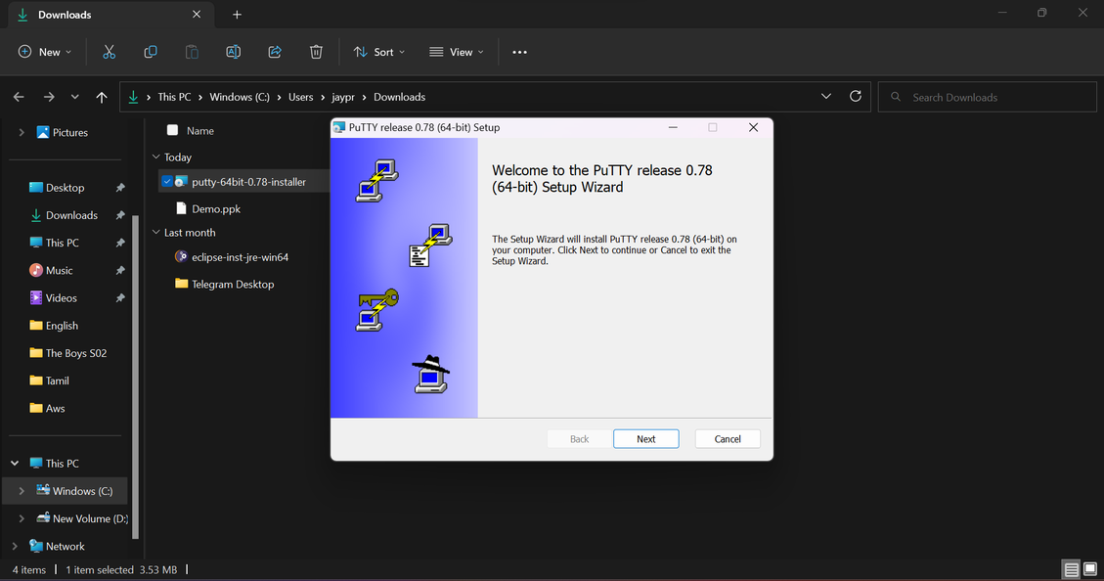

23.

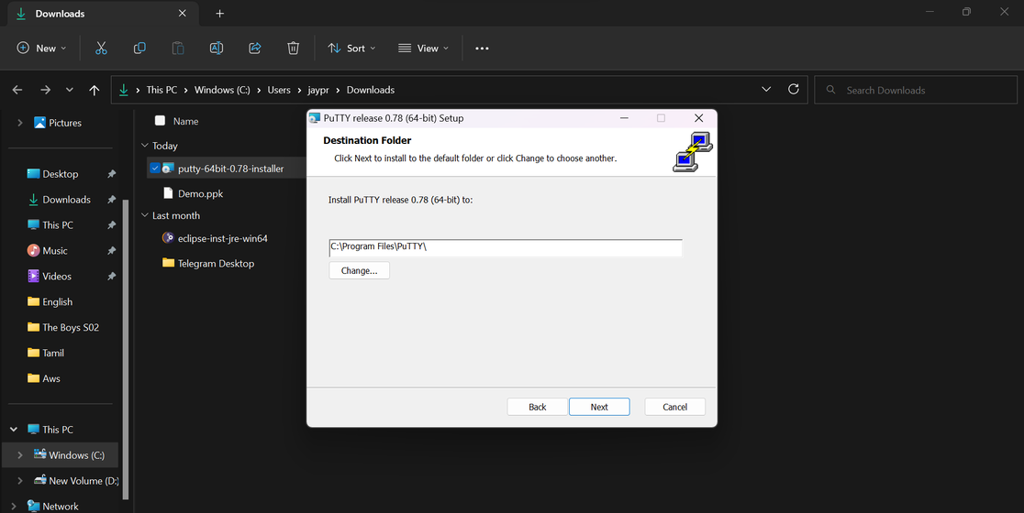

24.

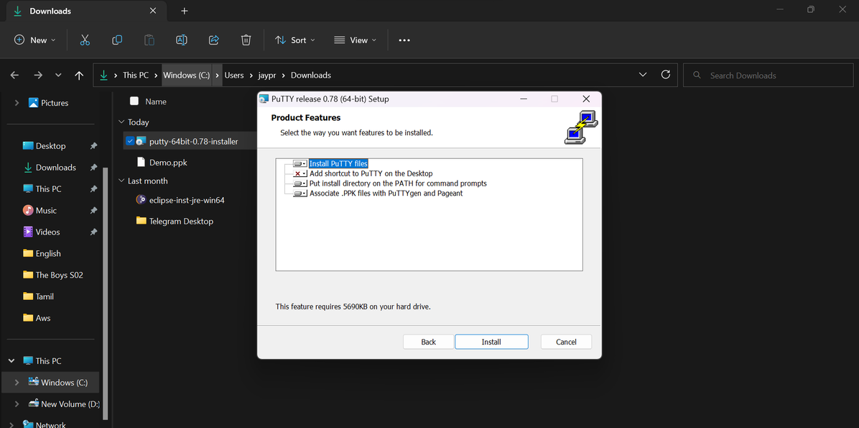

25.It Installed Successfully.

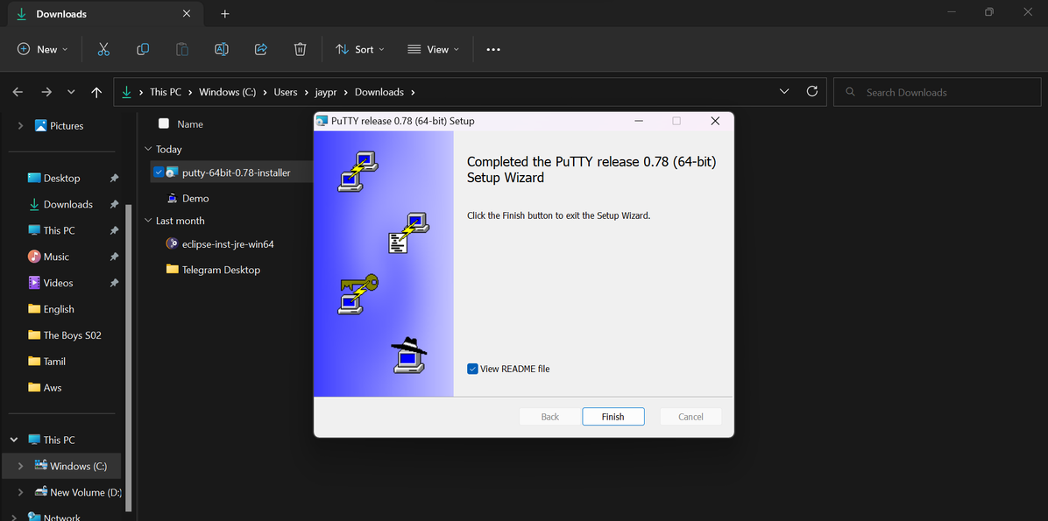

26.This window shows the Putty page.

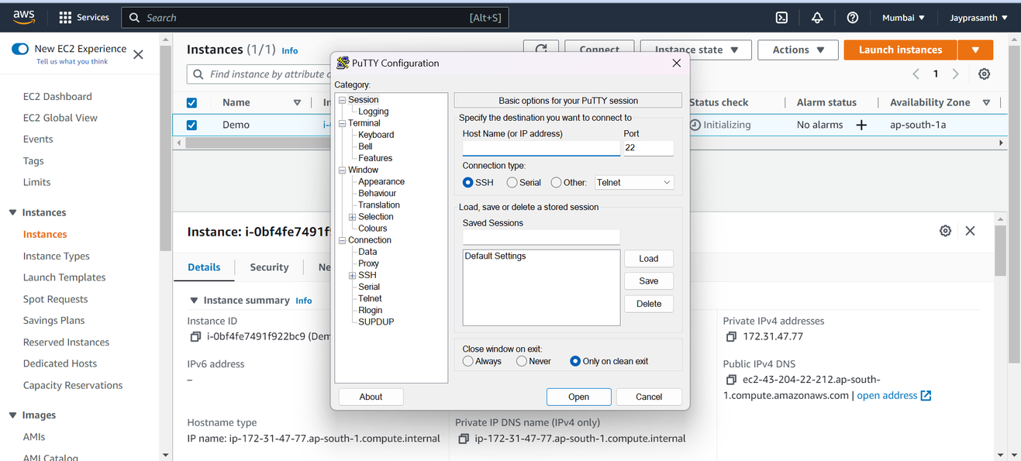

27.In putty, we paste the public IP address of Created Instances in Host Name

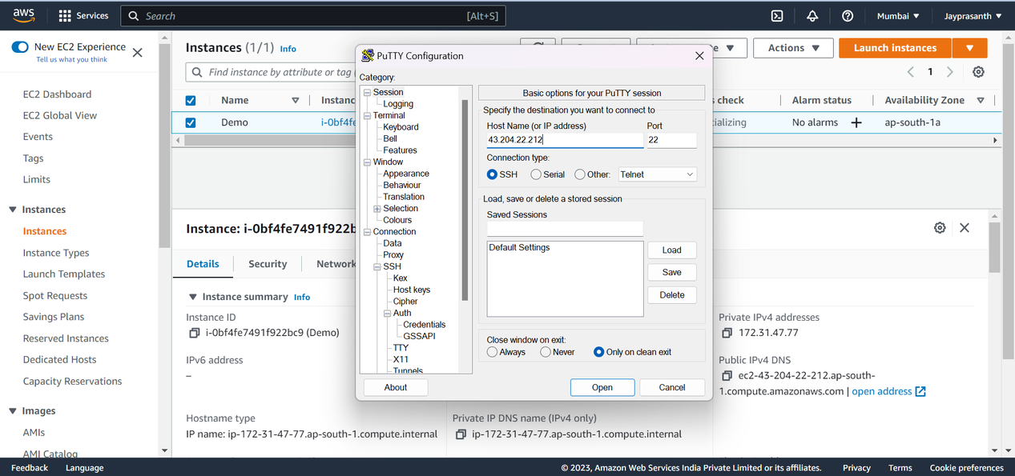

28.Then select SSH --> Auth --> Credentials and Paste Key pair and click open.

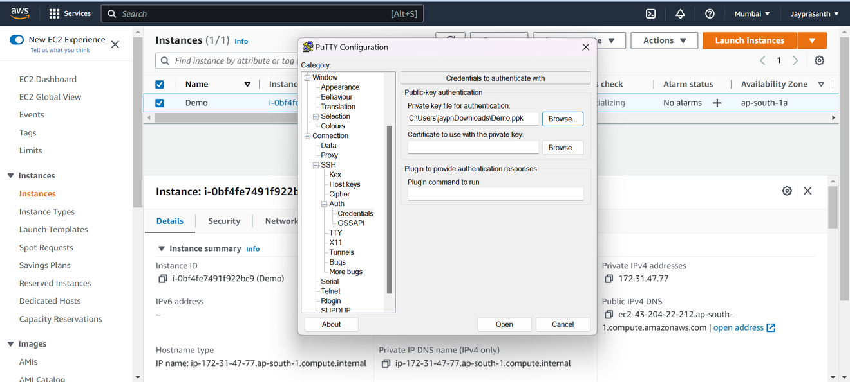

29. ec2-user is the Login user.

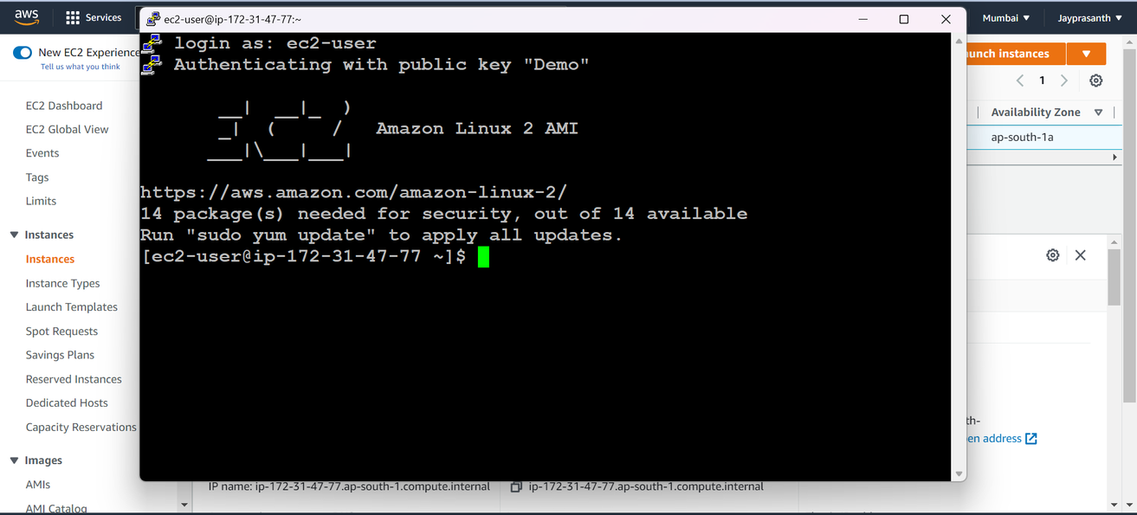

30.Then Finish all Service, We need to Terminate, Instance state and click Terminate instance

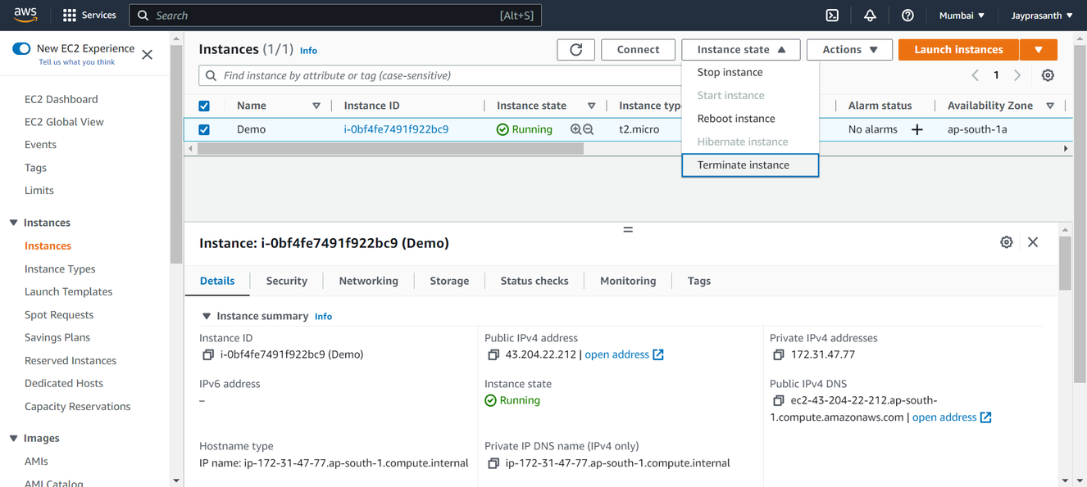

31. It terminated.

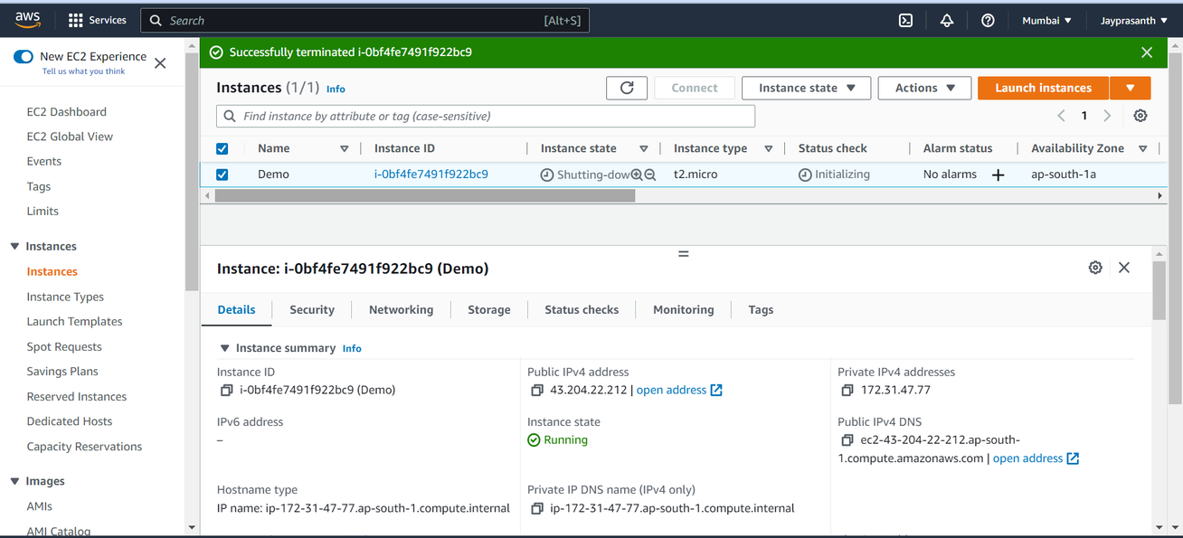

32. It is Elastic IP address, In this it is used to fix the IP address. To avoid, change of IP address

